**To make a hamburger menu**

1. Start with a mobile artboard

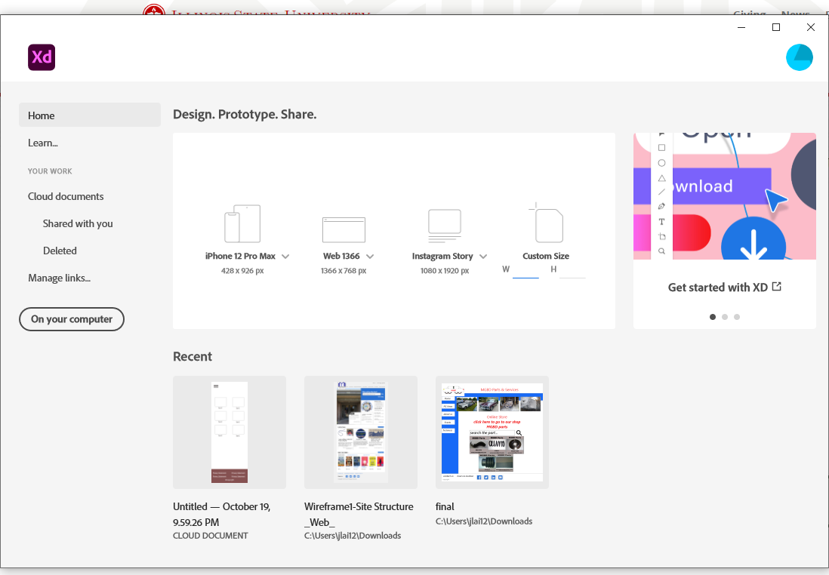

1. If you need to change the height of the artboard, click the title of the artboard, then drag the bottom line.

Title

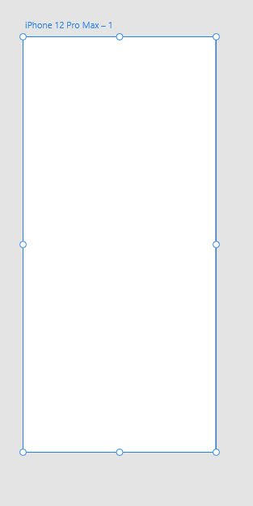

Drag this line to make the artboard longer

do not change the viewport height!

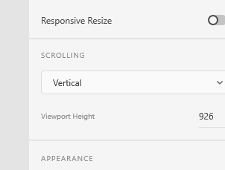

No, no. Do not change it! It is determined by the device.

1. Make three rectangles for the hamburger menu

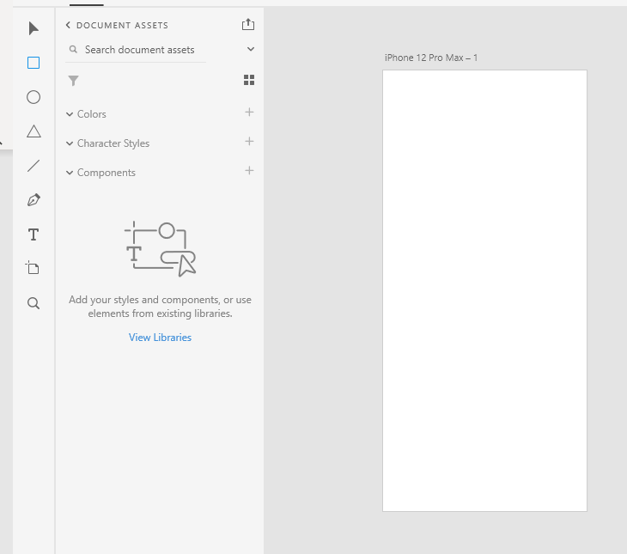

Hold Shift to select all three bars. Make the corners round

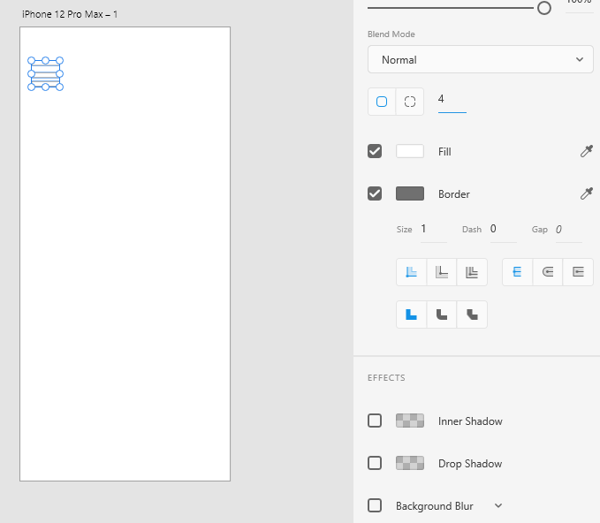

1. Change the color

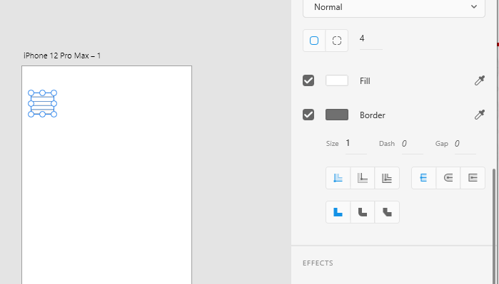

1. 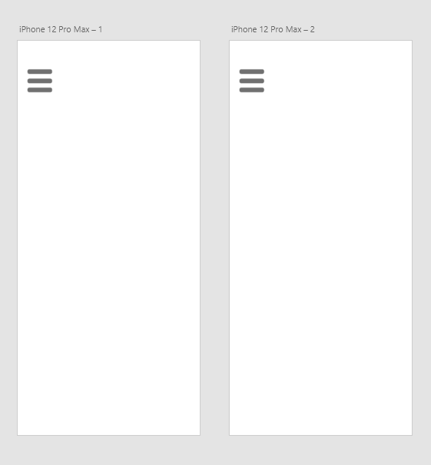Select the title of the artboard. Then copy and paste the artboard

Delete the middle bar on the second artboard. Change the angle of the first bar to 45, and the angle for the last bar to -45.

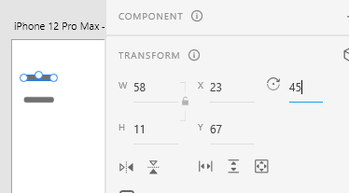

Select both bars while holding the shift key. Align them

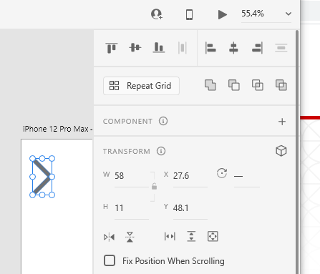

Add a big box as the background for the opened menu

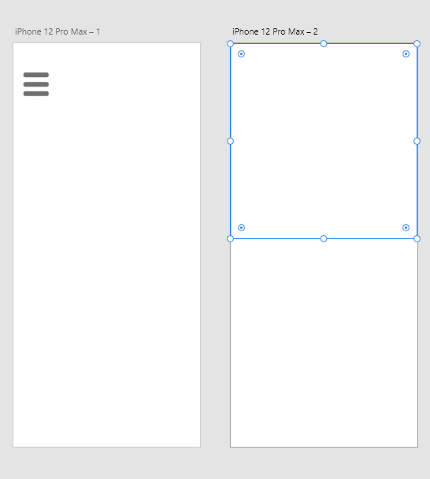

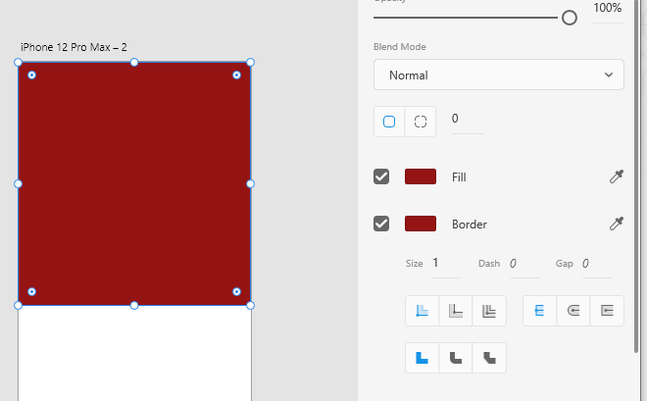Change the color for the background

You can change the name of the elements. If you do not see the items on the left, you need to select the bar first, then click the little icon in the lower-left corner.

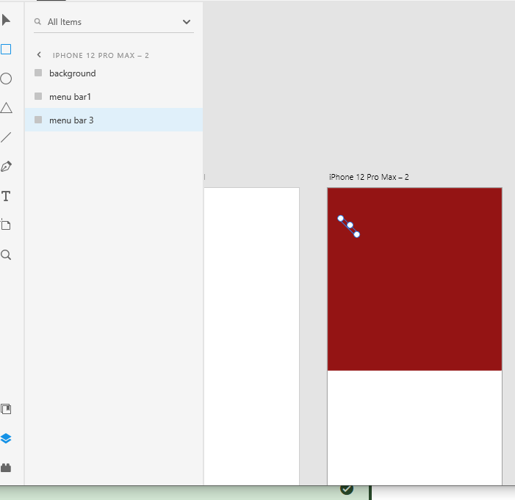

Move the background to the bottom, so that the hamburger menu bars will be shown.

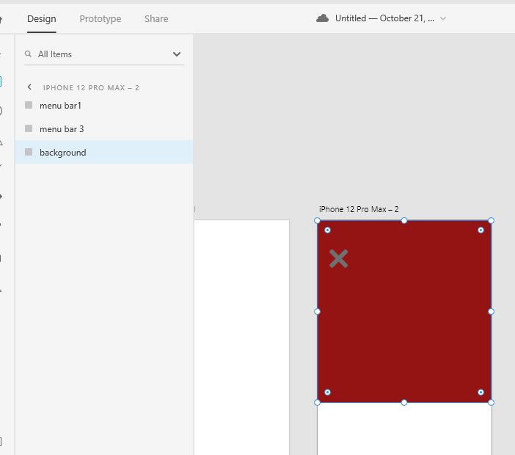

Add text for the navigation, and change the color and size

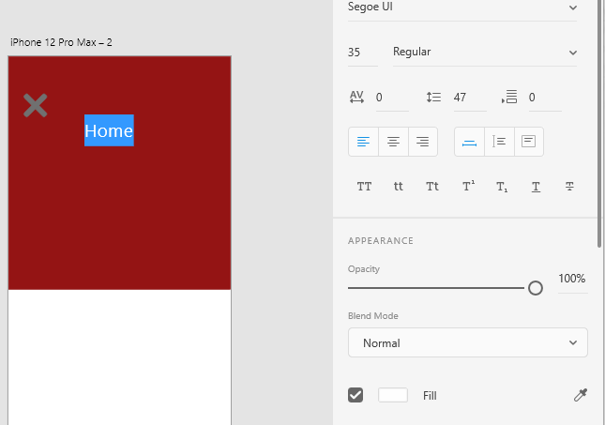

Add a box for hover effect

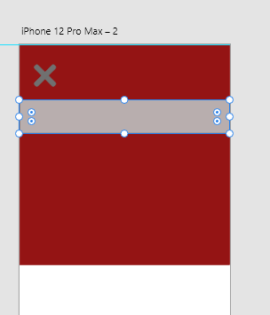

I give the bar a name “Hover background for home”, then drag it under the Home text

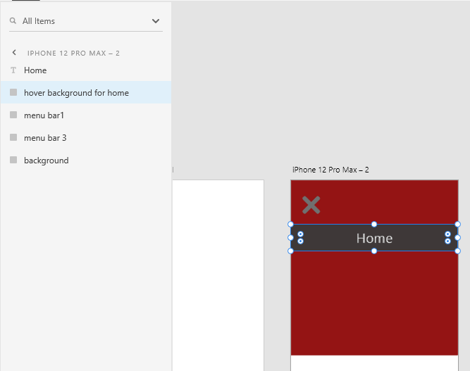

Select both the Home textbox and the background bar for it. Right click to make a component. I named it as Component Home.

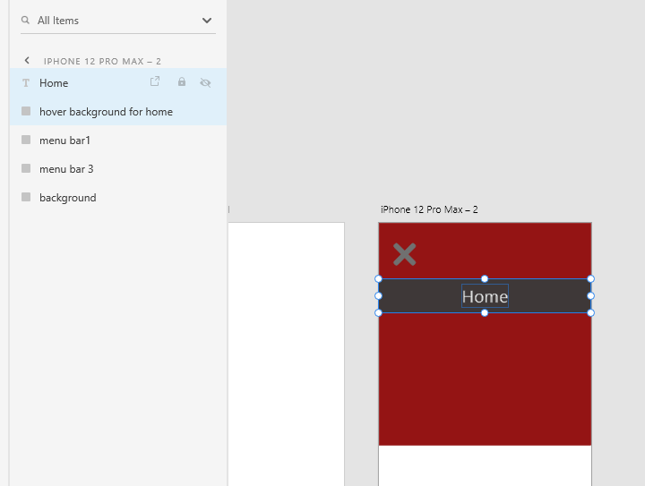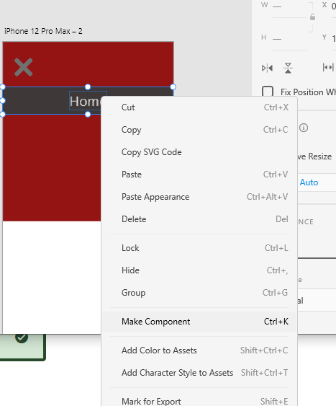

Add a hover state

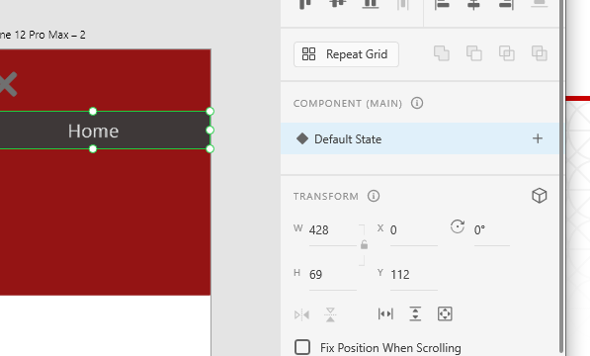

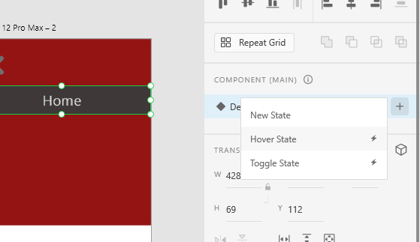

Select the Default state. Open the Component on the left by click the little icon.

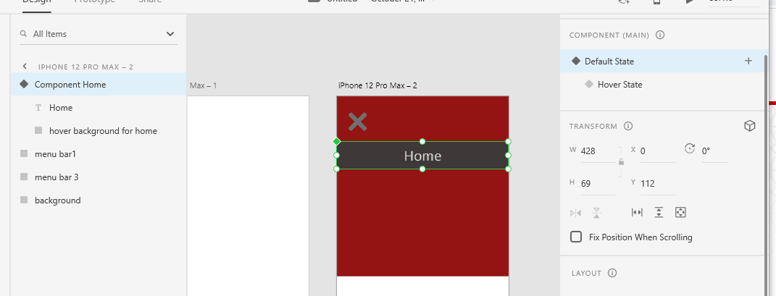

Select the Hover background bar only, then change the opacity to 0%

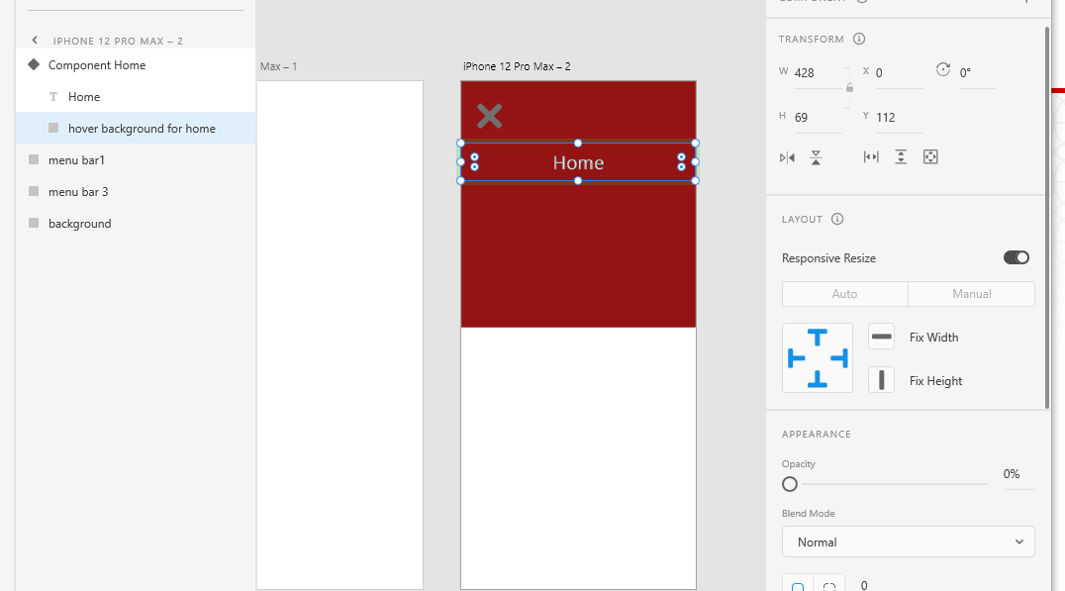

Select the whole component, select the hover state

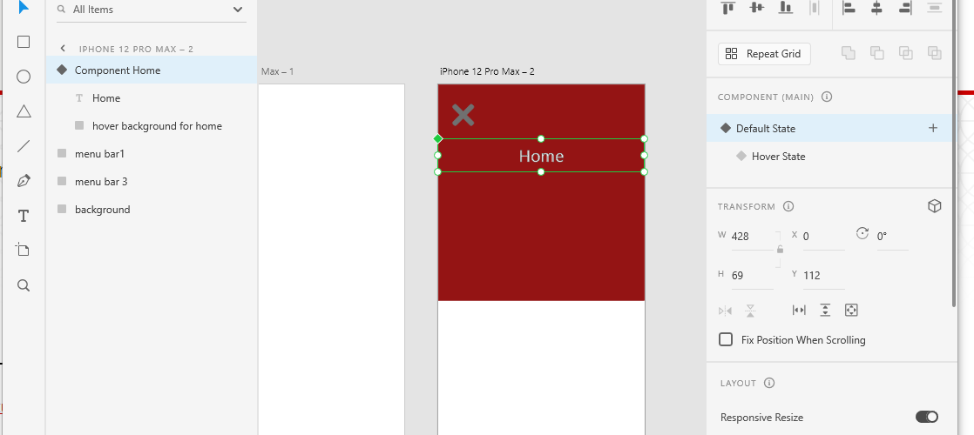

Then Open the Component, and select the background bar only. Change the opacity to 100%

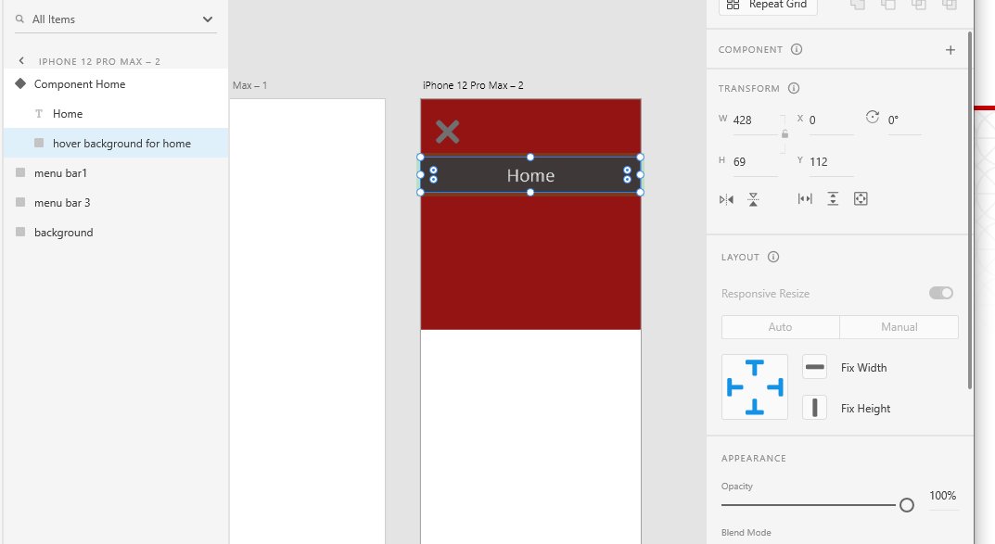

Select the whole component again, click the Default State

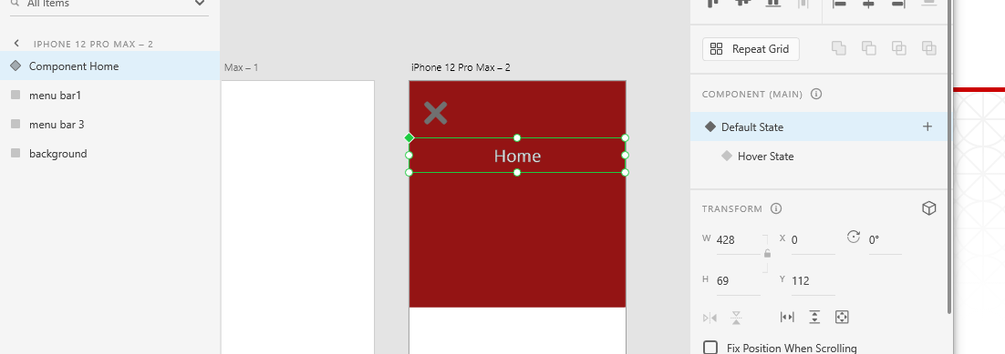

You can select the whole component and right click to duplicate it.

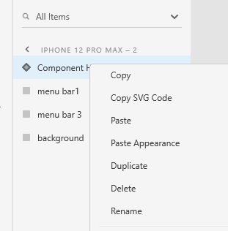

Rename the new component and move it to new place and change the text on it.

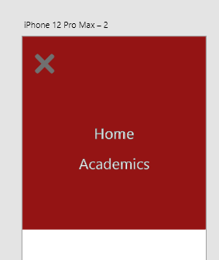

Go to prototype

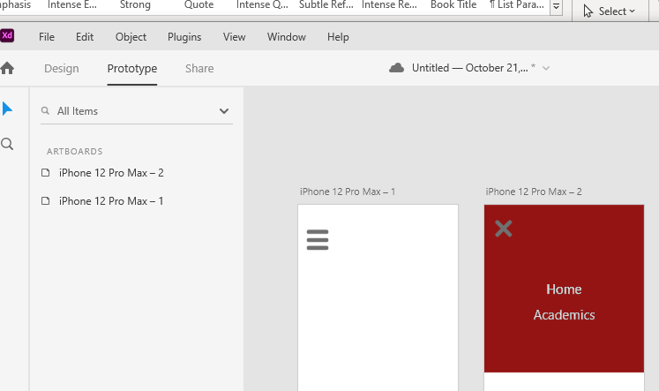

Select the three bars for the hamburger menu, and right click to group them 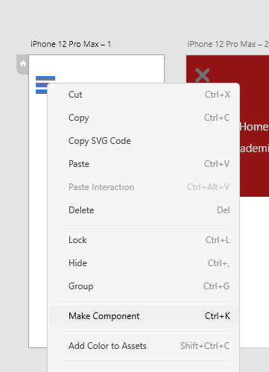

Group the x too

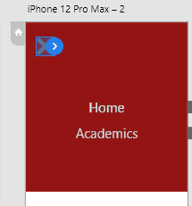

Select the hamburger menu and drag it to the second artboard

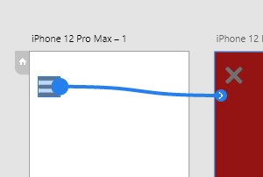

Select the x and drag it back to the first artboard.

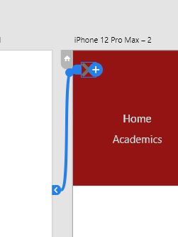

Click preview

